A small health disadvantage could cause a big employment disadvantage in a competitive labour market

# Introduction

## Para 1: Despite working age health improving in the UK, rates of working age inactivity due to ill health have increased.

Within the UK the economic inactivity rate of working age males has increased substantially over the last three decades(Faggio and Nickell, 2005) and is high in many other developed world nations.(Weir, 2003) The proportion of the male population claiming long-term sickness benefits (invalidity benefits, incapacity benefits, and employment and support allowance) has more than doubled.(Freud, 2007; McVicar, 2006; Moncrieff and Pomerleau, 2000) Despite this, self-reported measures suggest health has not declined during this period.(Kunst et al., 2005). By international standards, the UK is considered to have some of the toughest eligibility criteria in the developed world. Despite this, rates of IB/IVB rose during the 1980s/1990s, rising fastest between X and Y, then starting to plateau by … with the replacement of IVB with IB. The replacement of IB by ESA in… marked further developments in the eligibility criteria. As not all economic inactivity due to ill health will lead to a benefit, as for example IB was a contributory benefit, the true level of economic inactivity due to this cause is likely to be even higher.

Like unemployment rates, male invalidity benefit (IVB) and incapacity benefit (IB) rates during the 1980s and 1990s tended to increase during periods of recession, but unlike unemployment rates did not then subsequently decrease once the recessions had ended.(McVicar, 2006)

Both the New Labour and Coalition governments have identified the high incapacity benefits population as a major social, political and economic concern, and a number of high profile changes have been made to the benefits aimed at reducing the size of this population both by raising the threshold of ill health required to claim the benefit, and providing greater support and incentives for claimants who wish to reenter the labour market and get a job.(Black, 2008; Coalition, 2010; Freud, 2007) Despite early evidence for the most employment-focused of these schemes, Pathways to Work, appearing encouraging(Adam et al., 2006; Blyth, 2006; OECD, 2005), later evidence suggested the scheme had only very limited longer-term effectiveness(Bewley et al., 2007; Bewley et al., 2008; DWP, 2009) and was not cost effective.(Adam et al., 2008; Morse, 2010) The Coalition government currently plans to replace Pathways to Work with a new initiative, The Work Programme, by Summer 2011.(Easton, 2011; Simmonds, 2011)

The replacement of IB with Employment and Support Allowance (ESA), and with it the replacement of ‘sick notes’ with ‘fit notes’,(BBC, 2010) and the Personal Capability Assessment (PCA) with the Work Capability Assessment (WCA) as the means to assess eligibility has been controversial, with questions raised about the new test’s ability to sufficiently recognise the adverse effects of mental health conditions and fluctuating conditions.(Anonymous, 2010; Dryburgh and Lancashire, 2010; Gentleman, 2011) WCA also appears to have a generally higher threshold than PCA, with reassessments of existing IB claimants categorising around 30% of claimants as only eligible for JSA, and 40% as capable of some work and so eligible for the lower-paying employment support (ES) component of ESA.(Groves, 2011) The accuracy of the test is also in doubt, with around 40% of appealed decisions overturned.(Margrath, 2010)

## Para 2: Explanations as to why this has occurred have been very politicised.

Explanations for the rise in economic inactivity have been heavily politicised. X has suggested that the rise is due to a ‘dependency culture’. Related to this people have said that people have become less stoical, and so feel themselves unable to work when their level of health falls below a threshold that works of previous generations would have struggled through. X has suggested that political ‘gaming’ of national statistics have been a significant reason for the increase in IVB numbers in the early 1990s, as benefits agencies were pressured centrally to shift older workers, especially formers miners, from unemployment benefits to invalidity benefits to make the recession look less bad. Other commentators have suggested that much of the cause could be due to the workplace becoming increasingly stressful, leading to increases in rates of mental ill health. Many government initiatives in recent years have identified the rises in economic inactivity in working age people as a social problem in need of government intervention. Interventions aimed at addressing the problem include [pathways] + ½ others.

# Methods

## Para 1: We developed a simple mathematical model that indicates how this could have occurred due to labour markets becoming more competitive.

We developed a simple mathematical model which indicates how the patterns observed could have done so because labour markets became more competitive. Mathematical models are commonly used in health technology assessments to help NICE and other health based decision making organisations make coherent, evidence-based decisions. The role of this model is more as tool for exploring the logical consequences of making a series of assumptions about job selection processes. One of the classic applications of this sort of modelling approach is Thomas Schelling’s Racial Segregation model, which showed that even a slight preference towards one’s own racial or cultural group could lead to high levels of neighbourhood segregation. The advantage of formalising assumptions in this way is that it indicates when the macrobehavior of a system composed out of many elements whose micromotives are known are not intuitively knowable. In the case of working age economic inactivity, we can see that there has been a large increase in the individual level ill health we might expect to be the cause of this. This model shows how a combination of a number of factors could contribute to these changes.

## Para 2: The model formalises a number of assumptions and shows what they imply if combined

The model formalises a number of assumptions about labour market selection and health to show why they logically imply. These assumptions are: 1) that getting a job is essentially a winter-takes-all process; 2) that health is one of a number of factors that influences how ‘fit’ a candidate is likely to be for a job; 3) that people have ‘good days’ and ‘bad days, variation in performance, but that this variation is around a central level; 4) that people in poorer health have on average a lower level of job fitness than otherwise similar people in good health. Additionally, as small number of technical assumptions needed to be made in order to operationalize the model in practice. The assumption was also made in interpreting these result’s that if someone’s probability of getting a job following an interview was below a certain threshold then they would effectively become ‘unemployable’ and so more likely to be economically inactive rather than continue jobseeking. These assumptions will now be discussed in more detail.

## Para 3: There is the assumption that getting a job is basically a winner-takes-all process

There is the assumption that getting a job is essentially a winter-takes-all process. Through it sounds obvious, an implication of this is that if on candidate’s performance in the selection process is 95% as good as another candidates, then this candidate will not receive 95% of the ‘reward’ for this performance. An implication of this assumption is that the relationship between inputs and outputs can be nonlinear, meaning that small differences in fitness could, in some situations, lead to large differences in outcomes. Although it may be argued that there are exceptions to this assumption, and ways in which the assumption represents a gross simplification of the selection process, this should be recognised as the usual situation. Possible exceptions are cases where the performance of all candidates are so bad that the employer chooses not to offer the position to anyone, or conversely cases were two or more candidates for a single position are so good that, if discretion allows, more than one candidates is appointed. It is also common that getting a job as more a kin to a triathlon than a single race, involving multiple stages of selection each testing slightly different kinds of aptitude.

## Para 4: There is the assumption that people have an average level of fitness and there is some variation between these levels.

There is the assumption that people have an average level of fitness and some level of variation around this. This is to say people have ‘good days’ and ‘bad days’, and so a candidate could make a very good impression with an employer when they are performing near their peak but a very bad impression on other occasions. Although there may be factors which systematically affect how someone performance, such as the time of day, establishment or otherwise of a sense of rapport in the first minute of the candidate-employer encounter, personal issues prior to the interview and so on, such factors are considered completely random at the level of abstraction of this model.

## Para 5: There is the assumption that if a person’s employment level is below a certain level they are effectively ‘unemployable’ and it may be rational for them to ‘choose’ economic inactivity over job seeking

There is the assumption that if a person’s employability falls below a certain threshold then they effectively become ‘unemployable. This should not be considered a strong assumption amongst older working age people as there may only be a few years of working age remaining, and seeking employment takes some of this limited time up. If, for example, a 62 year old has specialised for the previous 40 years in a particular occupation, and there are currently only 10 new opportunities in that field per year, and the candidates needs on average to apply for 100 positions to be offered one job then it will take that person on average to years to get a job. If the retirement age is 65 then that person is effectively ‘unemployable’ as the could expect employment *after* they are due to retire, and so due to move beyond working age. Among younger people, the causes of potential ‘unemployability’ are likely to be somewhat different, and relate more to psychological and rational economic factors. If job seeking is an activity requiring ‘resilience’, and this is essentially a finite psychological resource, then enough rejections may put the candidate off job seeking enough that they feel more content not seeking employment any more. At the level of abstraction of this model, the different causes of employability are not relevant, and nor are differences between types of candidate. Instead, there is simply assumed to be a d single threshold at which people become ‘unemployable’

## Para 6: There is the assumption that there are just two types of people in the labour market: ‘healthy’ people and ‘sick people.

There is the assumption that there are just two types of people in the labour market: ‘healthy’ people and ‘health impaired’ people. Further to this it is assumed that ‘health impaired people’ have, as a result of their health impairment, a lower level of job fitness on average than healthy people. Again, this represents a simplification reality in a number of ways. : job fitness depends on a range of actors, such as qualifications, experience, demographic characteristics and so on. However, as the purpose of this model is to consider the effect of lower health on fitness when most other factors have been held constant, this added layer of complexity is not modelled. Additionally, the type of ill health and the type of job can be expected to interact: poor physical health is likely to affect people’s capacity to perform manual labour than non-manual labour, for example, and mental health deficits perhaps more likely to impair someone’s capacity to perform some sorts of non-manual labour. Again, at the level of abstraction of this model, such additional levels of complexity are disregarded, although the potential for developing the model to incorporate such factors will be discussed later in this paper.

## Para 7: The model takes the following form

The way the model is implemented id described briefly as follows: a job selection process is represented by selecting from a series of candidates who each demonstrate a given level of performance of that position. The performance that each candidate demonstrated on that occasion is represented by a random draw from that particular candidate’s ‘performance distribution’. The ‘healthy’ candidates are all represented by the same performance distribution, and the health impaired candidates by this same distribution by shifted down by a given amount, d. The model simulates the proportion of trials where a health impaired candidate ‘wins’ a job over one or more healthy candidates. A number of variations of this model are run, for a wide range of permutations of k, the number of healthy candidate the health impaired candidate completes against, and d, the degree of job fitness disadvantage due to ill health that the health impaired candidate has. In order to operationalise the model, the Normal distribution was used to represent variation in candidates’ performance, and the results are likely to be somewhat contingent this choice of distribution. The R code used to perform the simulations is presented on the appendix. The process is shown graphically in Figure 1 below. Although an analytic solution to the problem is possible when using this distribution, the simulation approach has the advantage of being relatively easy to produce and follow, so of course being readily adaptable to the other distributions and the incorporation of different assumptions and layers of simulation complexity.

**Employer’s appraisal of candidate’s job fitness**

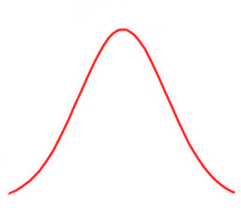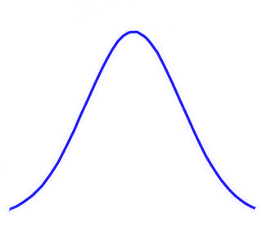

B

A

*d*

***Job 1***

***Job 2***

***Job 3***

***Job 4***

*Worse*

*Better*

Figure 1 Stylised job selection model

# Results

## Para 1: The relationship between p(job) and d is as follows

The relationship between the probability of winning a job and the degree of health-related employability disadvantage is shown in figure X below. The results below are where k =1, i.e. there is one competitor in average health against one health disadvantaged candidate. We see that the probability of the disadvantaged candidate presenting as the better candidate than the other candidate in average health decreases monotonically with the degree of disadvantage, d. In the case presented here this result is analytically solvable and deducible, as it simply relates to the degree of overlap between two normal distributions, one with mean N(0, 1) and the other with N(0d, 1). The analytic solution in this simple case therefore is ….. This availability of an analytic solution means the validity of the simulation results can be assessed in this instance, and are shown to be accurate. The advantage of the simulation approach is that it can be applied relatively simply to more complex of intractable variations, allowing researchers to concentrating on formalising and exploring the implications about social epidemiological processes, rather than on understanding probabilistic theory and calculus. This is demonstrated later.

## Para 2: The relationship between p(job) and k is as follows

The relationship between the probability of a health impaired candidate winning a job and the number of competitors for that job is shown in figure X below. Here a fixed level of disadvantage (d =0.5) is assumed in all cases, but the number of competitors is varied between k = 1 and k=15. If is see that as the number of competitors increases the probability of winning a job by the health impaired candidate decreases. Of course this pattern would be the case even where the candidate of interest had the average level of health, due to the winner-takes-all nature of the selection process. Because if the initial disadvantage, however, the probability of getting the job is lower than what would be expected of a nonimpaired candidates irrespective of the number of candidates. The bootstrapped 95% confidence intervals are shown as well. Again, these findings are largely intuitive and demonstrate that the model appears to be working properly.

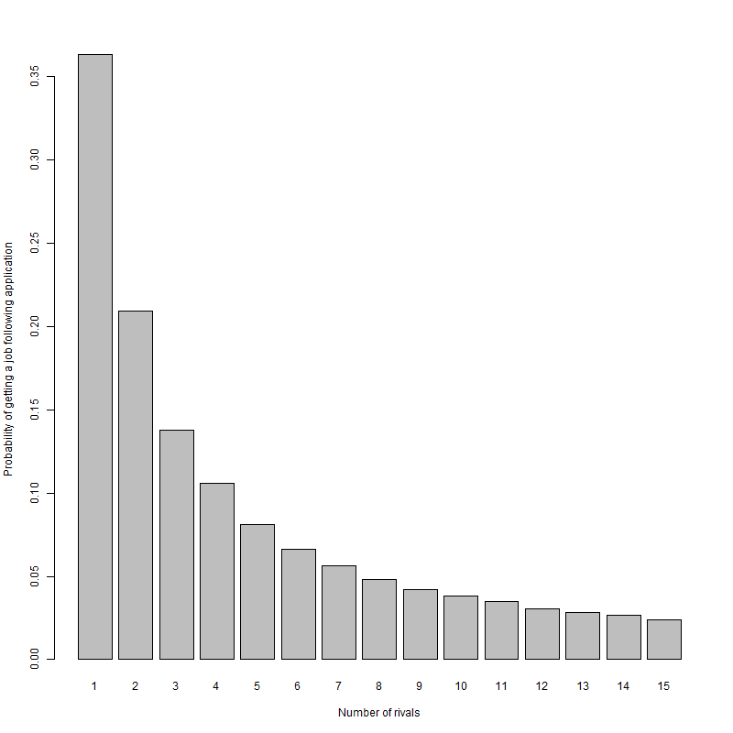

## Para 3: The relationship between p(job) and (d, k) jointly is as follows

The way that the number of competitors k and degree of disadvantage d jointly affects the probability of getting a job is shown in figure X below. Figure Y presents the same relationship using the equivalent measure, expected number of applications necessary to get a job. It is see that the effect of increasing the number of competitors for a job, as would be expected as a result of the labour market becoming more competitive, is to reduce the probability of getting a job irrespective of the degree of disadvantage. In terms of the guiding focus behind this work, understanding how increased labour competition could render a small level of ill health disadvantage into a substantial employability disadvantage, it is seen that someone with a given level of health disadvantage will face an increasing challenge to their getting a job as the number of competitors per place increases. It is further noted that this relationship is nonlinear, such that both d and k have to be specified in order to identify what the effect on employability is. As has been stated previously, the precise values predicted have not been calibrated empirically, and just exist to show how this nonlinear relationship could emerge as a result of modelling a series of relatively innocuous assumptions about social and economic factors which could mediate health factors.

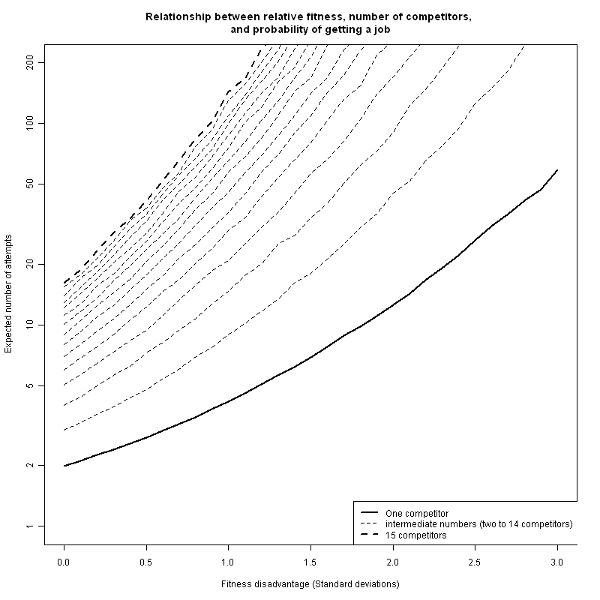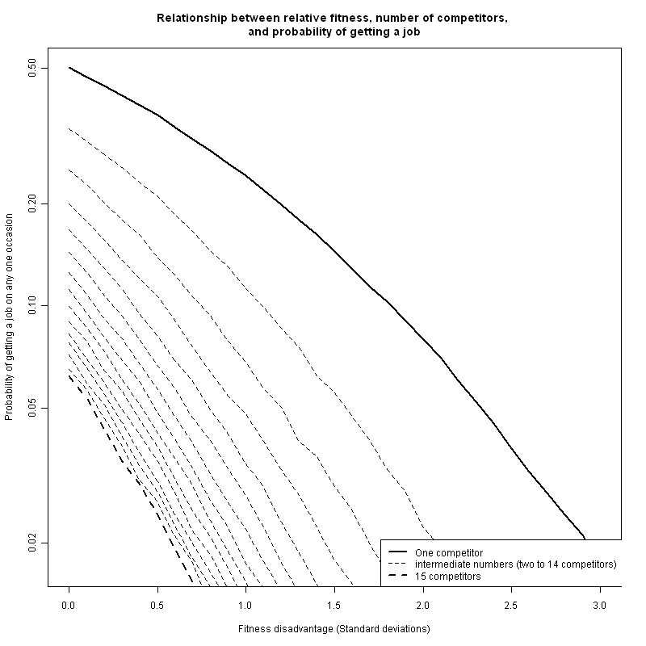

## Para 4: Unemployability as a threshold

In order to see how the relationships presented so far indicate how increases in economic inactivity due to ill health could increase despite there being no decrease in the health level of the working age, it is helpful to assume there exists a threshold at which a person effectively becomes ‘unemployable’. As discussed previously, this threshold could be different for different groups, and it could exist for a range of reasons. It is thought of here as relating to a level of unemployability so low that it is no longer in an individual’s interest to pursue employment opportunities any further, and instead some form of economic inactivity becomes preferable. There are many people of working age who have health problems that make them eligible to receive employment and support allowance, or previously IB or IVB. Not all of those who could claim the benefit and associated economically inactive category will do so. For example, many people of poor health will be working, albeit struggling to in many cases. Amongst these people it will not generally appear preferable to claim ESA, as employment generally pays better and has social standing. If that same person becomes unemployed, however, and as a result of a combination of their poor health and competition for jobs has a very low probability of getting another job, then it may be preferable for them to choose economic inactivity over jobseeking. The threshold at which this switch occurs is broadly what is meant here by ‘unemployability’.

## Para 6: How an increasing proportion of the working age population could become unemployable due to ill health even without worsening of population health

For example, if we assume that someone who requires on the average 200 applications to receive one job offer is at the ‘unemployability’ threshold, then we can observe how increased competition for jobs (increased k) will push an increasing proportion of the working age population into the ‘unemployable’ category. The threshold in this example is equivalent to the probability of employment of 0.005. With just one competitor per job, people remain ‘employable’ even where these health related disadvantage is 2.3. With two competitors in full health, a d of 1.6 starts to render someone ‘unemployable’. With three candidates without impairment per job, someone with a d of 1.3 becomes ‘unemployable’. This relationship continues with each addition competitor. In the example presented, with 15 unimpaired competitors per place, a person becomes ‘unemployable’ when their d level is only 0.2. Note that d refers only to the degree of disadvantage relative to the average ,and does not imply the proportion of the population with that level of d. A further nonlinear relationship between k, d, and the proportion of the population affected may be assumed, in that if the ‘unemployability’ threshold reaches a d level that is relatively common in the working age population, then a large rise in economic inactivity may emerge.

Four rivals, disadvantage of 1 sd

Eight rivals, disadvantage of 0.5 sd

11 rivals, disadvantage of 0.3 sd

Five rivals, disadvantage of 0.8 sds

154 4 1.0 0.04804

83 8 0.5 0.04829

56 11 0.3 0.04937

125 5 0.8 0.04945

# Discussion

## Summary of what found

This research found that, by combining a small number of common and plausible assumptions in the formal framework of a simple computer-based microsimulation, it appears plausible that economic inactivity related to ill health could increase substantially even without any increase in the levels of degree of ill health in people of working age. Instead, the way that increases in labour market competition could mediate and amplify the detrimental effects of ill health on employability could be key. This interpretation with evidence showing that it has become more difficult, not easier , to become eligible for healthy based benefits like IB, IVB, ESA; and evidence indicating that there has been no worsening in working age population health. Over the last two generations, however, there have been a number of severe recessions, translating into increased competition for jobs. The use of simple microsimulations in this way makes the logical implication of making a set of assumptions easier to explore and scrutinise.

## Shortcomings

The shortcomings of this model depend on the purposes for which it is intended. The use of mathematical models and computer-based microsimulation is commonplace without certain parts of the health sciences. For example, microsimulations are routinely used by NICE in order to produce estimates of clinical and cost effectiveness of a new health technology compared with standard practice. Although such models differ in their levels of clinical and technical sophistication, they are not immediately accessible, in general, to people not specialised in their construction and evaluation. The model demonstrated here is much simpler than these models in terms of the number of parameters used and the range of analyses conducted. It is intended primarily as a pedagogic tool for encouraging clearer thinking about this important economic and health issue. In using a model in this way it is important that the right balance is struck in terms of model sophistication and model accessibility; the shortcomings therefore relate to the extent to which this balances is judged to be wrong. If a stylised model with pedagogic purpose such as this is clear enough to nonspecialists that the assumptions involved in its construction can be challenged and alternatives suggested and implemented, then to an extend it has been shown to be fit for purpose.

The lack of empirical ‘calibration’ Assumption about Normal stochastic term. Assumption of equal variance in populations. Not incorporating ‘staying power’ issues (well enough one day to get a job, mot enough every day to keep a job). Discrete/categorical issues/handing

## How relates to other findings

Recent research by this author has indicated a complex relationship between gender, occupational class, and limiting long term illness as predictors of whether people are in work, seeking work or economically inactive. In particular, this research showed that the presence of a limiting long-term illness was much more strongly associated with being economically inactive for people of unskilled and semi-skilled manual labour backgrounds than nonmanual backgrounds; additionally, it showed this relationship to have grown much stronger since the 1970s. In terms of the variables included in this stylised model, there are two possible, and not mutually exclusive, explanations for these observations. Firstly, it may be that a ‘limiting long-term illness’, as responders were asked to interpret it, was more likely to be a physical than a mental disorder, and as a result was likely to be the sort of health deficit which led to a larger job-specific health deficit for manual than non-manual work. Secondly, the long transition towards an increasingly post-industrial economic is likely to mean that there is a greater scarcity of manual than nonmanual work, and so k is greater for these occupational groups than non-manual workers. This stylised model owes a conceptual debt to work by Beatty, Fothergill and McMillan [refs] in relationship to ‘hidden unemployment’, and so its relationship to this research is not coincidental.

Beatty & Fothergill

Mine

Two/three others.

## Implications for research

This paper has illustrated the potential benefits to epidemiological research and theorising about epidemiological processes of using a computer based microsimulations as tools for teaching out the implications of making and combining a series of assumptions about an epidemiological phenomenon. The use here of a microsimulation model as a thinking tool for pedagogic aid contrasts with uses more common in the health sciences such as a decision tool by NICE for making resource allocations models and synthesising multiple sources of evidence. There are two avenues here for the development of what is presented here into further research. Firstly, the model developed here could be made more sophisticated, incorporating and being parameterised by various forms of evidence from the literature. Calibration could be performed by comparing the predictions of the model to reality over periods where the data are already known. Secondly, the spirit of the approach described here could be followed to encourage health researchers to adopt the stylized and pedagogic modelling approach for exploring other complex health science areas.

Adding complexity and empirical calibration

Survey research on number of jobs applied for per success

Survey into possible class disparities in health of women of working age who don’t work

Application of approach to other forms of disadvantage 9e.g. employment, qualifications

## Implications for practice

Recognition that once someone of poor health becomes unemployed it may be very difficult for them to get a job again.

Consideration of sheltered employment schemes to keep people in labour market

Recognition that efficient and accessible labour markets may be mutually incompatible.

# Appendix: R code

# K : rivals

# d : disadvantage

# n : number of simulations

n <- 100000

K <- 1:15

D <- seq(0,3, by=0.1)

Output <- expand.grid(k=K, d=D, prob=NA)

for(d in D){ # for each of a range of levels of disadvantage

for (k in K){ # for between 1 and 15 rivals

A.win <- vector("numeric", n)

for (i in 1:n){

B <- rnorm(k) # k draws from a normal distribution with mean of 0 and sd of 1

A <- rnorm(1, -d) # one draw from a normal distribution with a mean of -d and sd of 1

A.win[i] <- as.numeric(A > max(B)) # produces a vector with 1 if A is the greatest number; 0 otherwise

}

prob.A.win <- sum(A.win) / n # calculates the proportion of times where A is the greatest value

Output[Output$k==k & Output$d==d, "prob"] <- prob.A.win

}

}

####